Name: MEHTA NIHAR NIKHIL

Roll No: 13D100011

Q1 Harris Corner Detection

Code:

function [corner_coeff]=myHarrisCornerDetector(orig_image,k,sigma_x,sigma_y)

min_intensity=min(min(orig_image));

max_intensity=max(max(orig_image));

orig_image=(orig_image-min_intensity)/(max_intensity-min_intensity);

[row,col]=size(orig_image);

orig_image=double(orig_image);

partialX=Ix(orig_image);

partialY=Iy(orig_image);

A=partialX.^2;

B=partialY.^2;

C=partialX.*partialY;

kernelX = [[-1, 0, 1];

[-1, 0, 1];

[-1, 0, 1]];

kernelY = [[-1, -1, -1];

[0, 0, 0];

[1, 1, 1]];

kernel=exp(-0.5*((kernelX.^2)/(2*sigma_x^2) + kernelY.^2/(2*sigma_y^2)));

A=apply_kernel(A,kernel);

B=apply_kernel(B,kernel);

C=apply_kernel(C,kernel);

eigen1=zeros(row,col);

eigen2=zeros(row,col);

for i=1:row

for j=1:col

temp_matrix=[A(i,j) C(i,j); C(i,j) B(i,j)];

eig_output=eig(temp_matrix);

eigen1(i,j)=eig_output(1);

eigen2(i,j)=eig_output(2);

end

end

trace=(A+B);

Det=A.*B-C.*C;

corner_coeff=Det-k*trace.^2;

figure, imshow(partialX), title('X derivative');

figure, imshow(partialY),title('Y derivative');

figure, imshow(eigen1),colorbar, title('1st eigen value');

figure, imshow(eigen2),colorbar, title('2nd eigen value');

figure, imshow(max(corner_coeff,0)),colorbar,title('Harris Cornerness measure');

radius=30;

threshold=0.1;

% perform non-maximal suppression using ordfilt2

n = ordfilt2(corner_coeff, radius^2, ones([radius radius]));

% display corner pixels on the original image

corners = (corner_coeff==n)&(n>threshold);

list=find(corners==1);

figure,imshow(orig_image),title('Corners on original image');

hold on

plot(ceil(list/row),mod(list,row),'r+', 'MarkerSize', 5, 'LineWidth', 3)

end

function [xderiv]=Ix(image)

kernel=[-1,0,1];

[row,col]=size(image);

xderiv=zeros(row,col);

for i=1:row

for j=2:col-1

xderiv(i,j)=sum(kernel.*[image(i,j-1) image(i,j) image(i,j+1)]);

end

end

end

function [yderiv]=Iy(image)

kernel=[-1,0,1];

[row,col]=size(image);

yderiv=zeros(row,col);

for i=2:row-1

for j=1:col

yderiv(i,j)=sum(kernel.*[image(i-1,j) image(i,j) image(i+1,j)]);

end

end

end

function [new_image]=apply_kernel(image,kernel)

[row,col]=size(image);

[krow,kcol]=size(kernel);

new_image=zeros(row,col);

midrow=floor((krow-1)/2);

midcol=floor((kcol-1)/2);

for i=1+midrow:row-midrow

for j=1+midcol:col-midcol

new_image(i,j)=sum(sum(kernel.*image(i-midrow:i+midrow,j-midcol:j+midcol)));

end

end

end

Original image

Derivative Images:

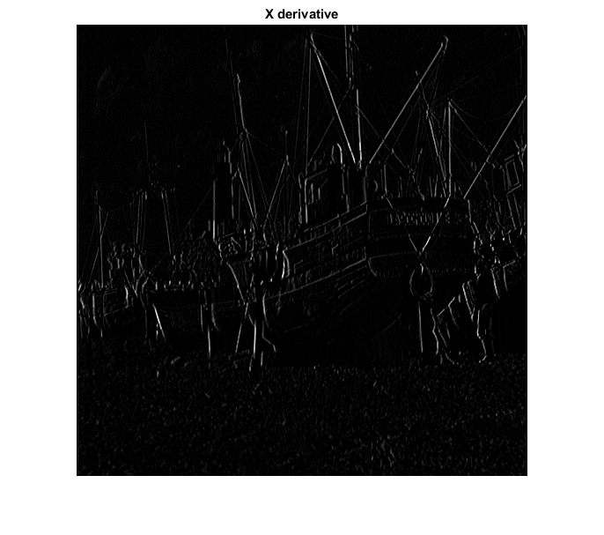

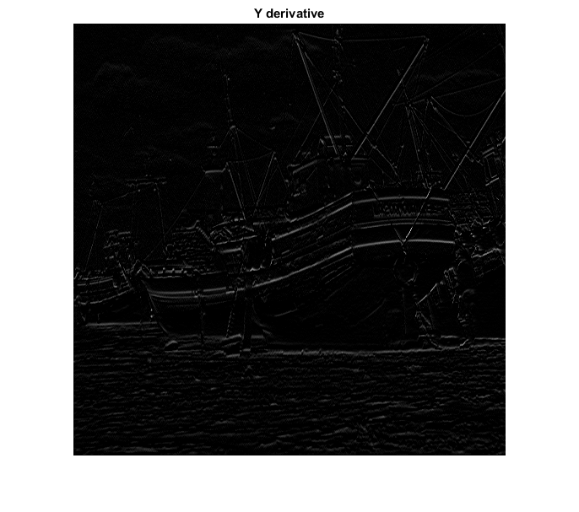

Eigen value 1:

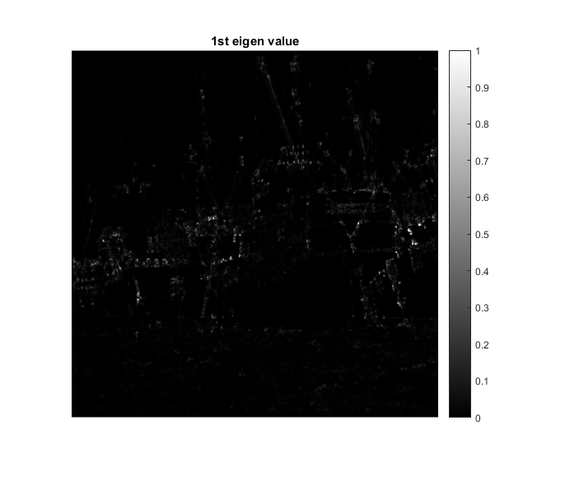

Eigen value 2:

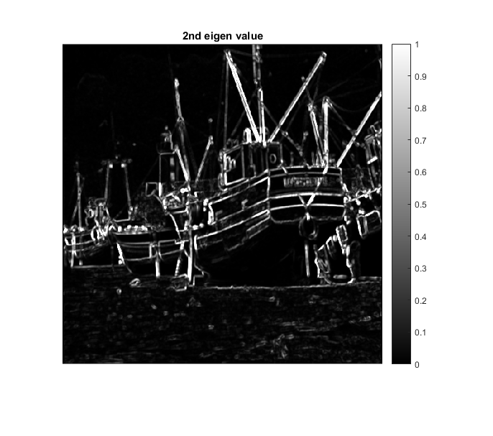

Harris Corner measure:

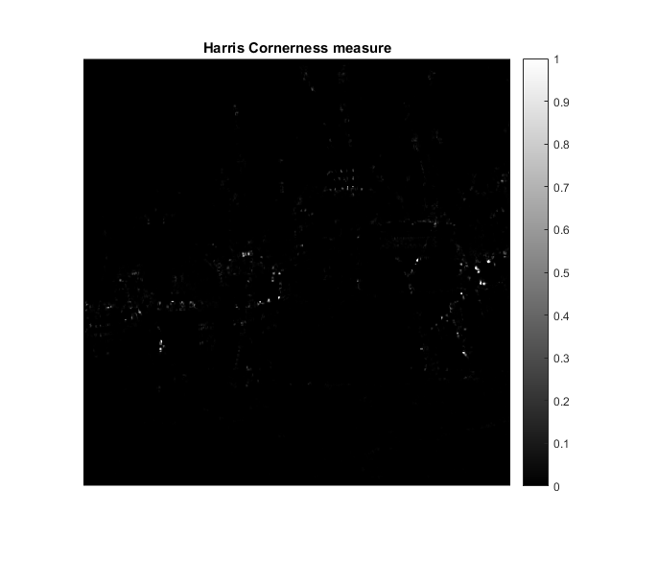

Final result:

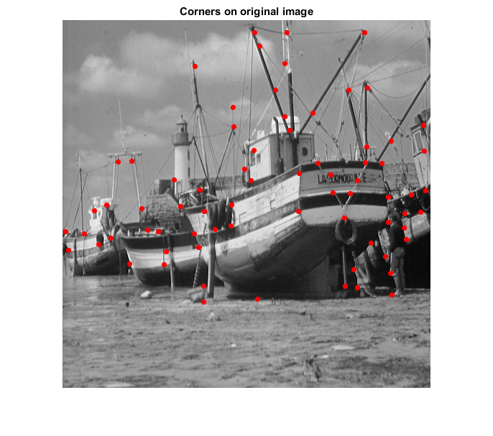

Parameters used:

K=0.05

Sigma_x=10

Sigma_y=10

Effects of parameters:

If K is decreased, more corners are captured. Generally the K value must be around 0.04-0.06. A higher value of K results in missing out of the corners.

If sigma_x and sigma_y are not used, then some corners are missed out because of the low gradient changes with the background.

If radius of thresholding is increased, less corners are captured. This must be an optimum so that neither specious corners appear, nor true corners are skipped.

If threshold parameter is increased, less corners of captured.